MRKun system source package reference

Purpose: The purpose of this document is to provide the detail for source package and to serve as a reference during the development phase.

Package location
All packages should be located in their respective directories under weblogic/myserver. SessionEJB goes under weblogic/myserver/ejb. Value object and the framework package go under weblogic/myserver/serverclasses. Servlet package goes under weblogic/myserver/servletclasses.

See figure below:

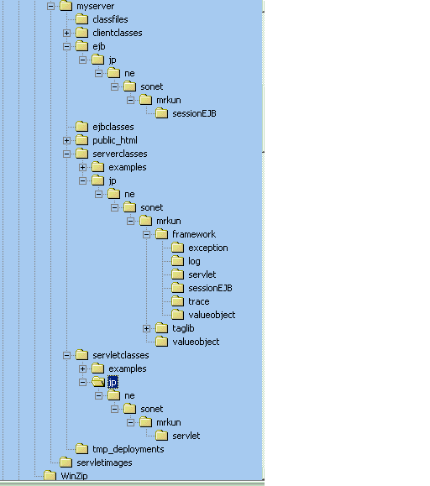

BaseXXX classes

All basexxx classes go under their respective sub-packages of jp.ne.sonet.mrkun.framework. Sub-package details as below:

Sub-package: jp.ne.sonet.mrkun.framework.exception for exception related base classes.
Sub-package: jp.ne.sonet.mrkun.framework.log for logging related base classes.
Sub-package: jp.ne.sonet.mrkun.framework.servlet for servlet related base class.
Sub-package: jp.ne.sonet.mrkun.framework.sessionEJB for session EJB related base classes.
Sub-package: jp.ne.sonet.mrkun.framework.valueobject for value object related base classes.
Sub-package: jp.ne.sonet.mrkun.framework.trace for event tracing related base classes.

SessionEJB classes

All sessionEJB classes and their interfaces go under jp.ne.sonet.mrkun.sessionEJB package.

Servlet classes

All servlet classes go under jp.ne.sonet.mrkun.servlet package.

Value object classes

All value object classes go under jp.ne.sonet.mrkun.valueobject package.

